Windsor Miners
15 March 2022

PROJECT PROPOSAL

Counter Strike: GO
Phase 1: EDA Analysis

I. Introduction 3
II. Team Structure 3
III. Needs/Problems 4
IV. Goals/Proposal 2
V. timeTable 2
VI. EDA aNalysis 2
VII. Next Steps 2
Viii. Appendix 2

- Introduction
The Game:
- Counterstrike is a FPS (First-Person Shooter) game in which two teams of 5 players face each other in a matchup. The game includes a Terrorist side (T) that is tasked to plant a bomb and have it detonated, and a Counter-Terrorist side (CT) that is tasked to defuse the bomb or prevent it from being planted. The game of Counterstrike is a best of 30 rounds, the winning team being the first to win 16 rounds. The 30 rounds are played in two halves of 15 on each side of the map. There are 7 maps in the map pool that are available to be played competitively at any given time. Matches are normally played as a 'bo3' (Best of 3) maps, with finals often played as 'bo5’s. Counterstrike has an economic system that governs the acquisitions of armour, weapons and grenades by the players.
Motivation:
- Online gaming world is full of FPS games, with CS: GO being one of the most sorted out game by online players. Most players (old or new) try to get along on the platform and try to hone their skills (both offensive and defensive) by playing competitive matches. But the other side of the story is that CS: GO platform has the highest dropout rate for new online gamers. With the game and maps becoming more and more competitive and complex it becomes extremely difficult for a new gamer to keep on going on the platform after certain time on the platform.

- Team Structure
A group of motivated and eager college students, who wants to learn and understand the
- Suhail Riyaz Ahmed
- Raj Bharatkumar Bhalodwala
- Bhavesh Trigunanand Mishra
- Luis Palacios Melendez
- Dhruvalbhai Sunilkumar Patel
- Amit Sharma – Group Leader

- Needs/Problems
- New online gamers need upfront guidance and insights for starting their online game journey. These insights can help the gamers to choose better maps, learn from top players/teams and use strategies (economic) that can raise their own interest in this complex gameplay. Eventually the gamer can perfect his own style of gameplay (offensive or defensive) by learning or copying from the very best around on the circuit.

- Goals/Proposal
Project Proposal:
- The team will take a descriptive analysis approach in which team will try to develop an analytic product to examine the data related to Players, Teams, Maps and Matches of the old CS:GO data. This data can help out new online gamers to gain insights related to the past trends of the game which can help them to gain strategic edge while starting their new online journey. The new gamers will be direct beneficiaries of the analytic trend data along game creators who will be benefitted indirectly by getting the benefits of better retention percentage of new gamers.
The analysis will try to give answers to some of the below few questions: -
- Which map get the most picked with high number of kills per round?
- Which are the top players in an event and can decided awards for MVP?
- How to save economy in game to maintain a good inventory?
- Where to start and what approach to take on a certain map?

- Timetable
Provide detailed information on the expected timetable for the project. Break the project into phases and provide a schedule for each phase.
 | Description of Work | Start and End Dates
Phase One
Phase Two
Phase Three

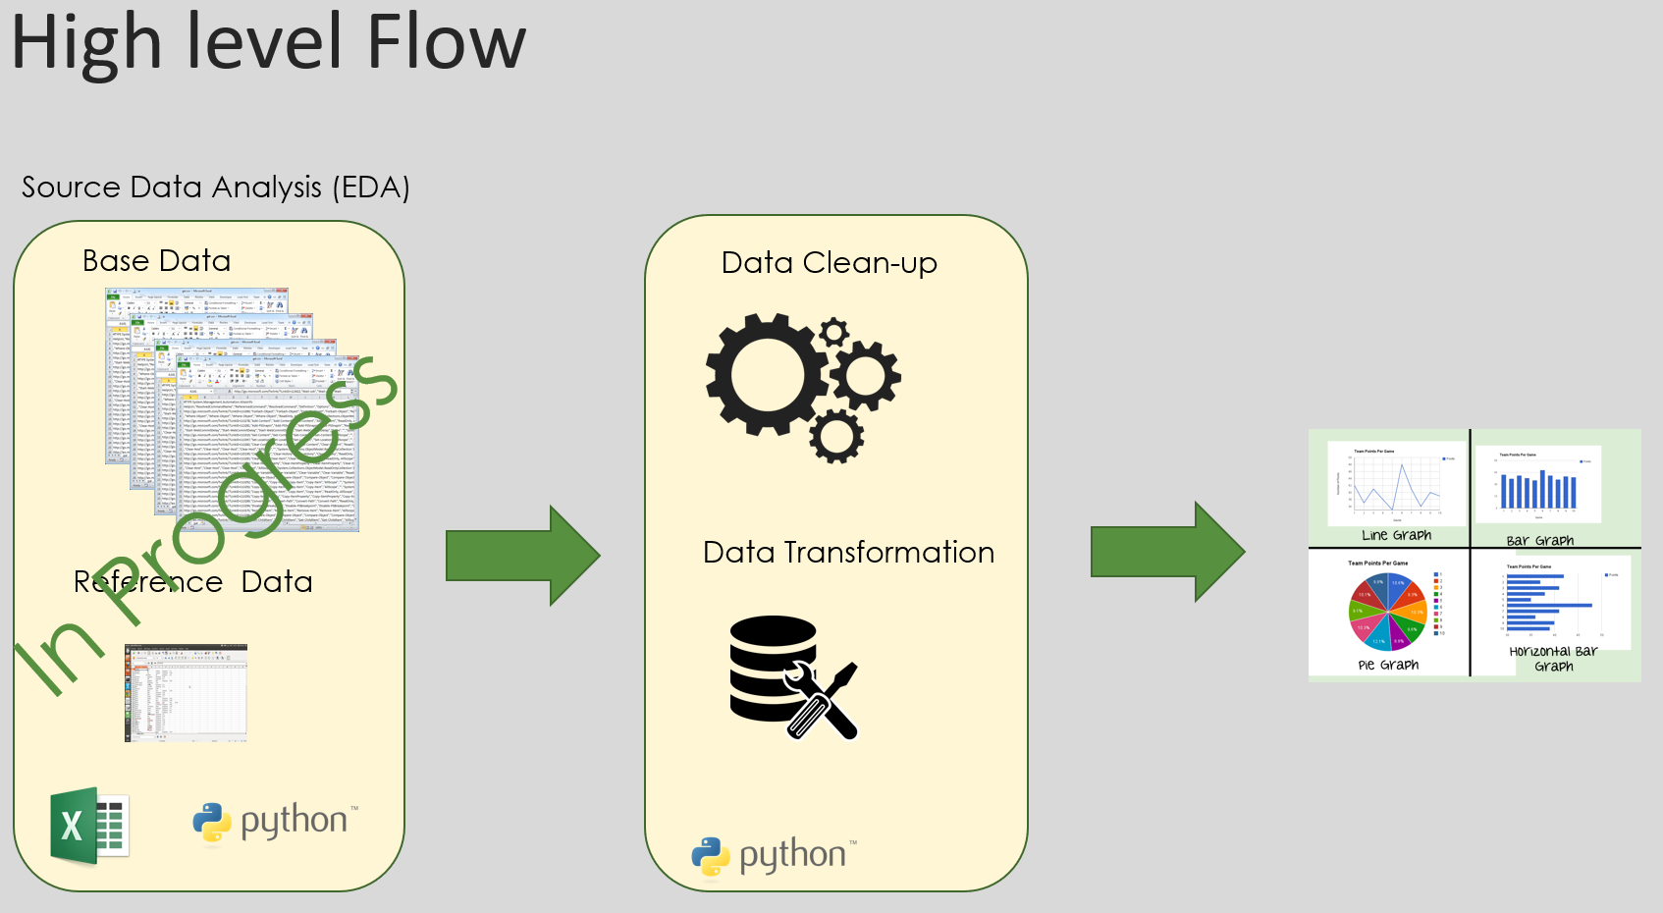
You can also use a Gantt chart for more detailed project timetable:
ACTIVITY | IMPLEMENTATION TIME |  |  | RESPONSIBILITY
1. Design and implement training program for  project management | Month 1 | Month 2 | Month 3
 | XXXXXXX |  |  | Program  Manager (PM)
1.1. Conduct needs assessment |  | XXXXXX |  | Consultant
1.2. Design training modules |  |  | XXXXXX | Consultant
1.3. Conduct training |  |  | XXXXXX | Consultant
2. Improve procedure for project management | XXXXXXX | XXXXXX | XXXXXX | Program  Manager
2.1. Conduct management audit of current  procedures |  | XXXXXX |  | Consultant

- EDA Analysis
List the key personnel who will be responsible for completion of the project, as well as other personnel involved in the project.
Client | [name]
Sponsor | [name]
Project manager | [name]
Team | [name], [name], [name], [name]

- Next Steps
Specify the actions required of the readers of this document.
• Next Step 1
• Next Step 2
• Next Step 3

- Appendix
Provide supporting material for your proposal here. It may be:
- Generic Project Proposal Template - Casual.pm
- https://www.kaggle.com/hugomathien/soccer
- https://data.cdc.gov/NCHS/Provisional-COVID-19-Death-Counts-by-Week-Ending-D/r8kw-7aab
- https://www.kaggle.com/deepann/4000-laptops-data-from-gadgets360?select=mobiles.csv
- https://www.kaggle.com/datasnaek/youtube-new?select=USvideos.csv
- https://simfin.com/data/companies/111052
- https://simfin.com/data/companies/1110567
- https://www.kaggle.com/mateusdmachado/csgo-professional-matches?select=results.csv
- https://www.kaggle.com/patrickb1912/ipl-complete-dataset-20082020
- https://archive.ics.uci.edu/ml/datasets/Pittsburgh+Bridges
- https://www.kaggle.com/karangadiya/fifa19
- https://www.kaggle.com/ramjasmaurya/best-cities-and-countries-for-startups-in-2021
- https://www.kaggle.com/datasnaek/youtube-new?select=USvideos.csv
- https://www.kaggle.com/tmdb/tmdb-movie-metadata?select=tmdb_5000_movies.csv
- https://www.kaggle.com/deepann/4000-laptops-data-from-gadgets360?select=televisions.csv
- https://www.kaggle.com/harlfoxem/housesalesprediction

